**Lambda Assignment**

1. **Write an application to perform basic arithmetic operations like add, subtract, multiply & divide. You need to define a functional interface first.**

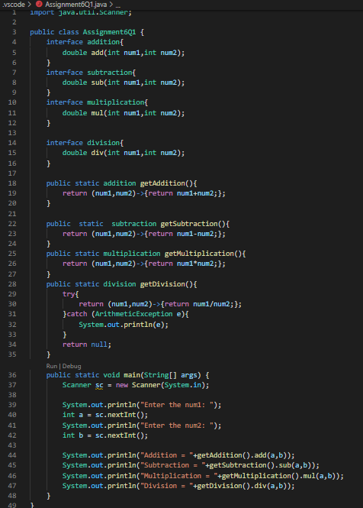

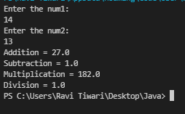

**Q2. Write an application using lambda expressions to print Orders having 2 criteria implemented: 1) order price more than 10000 2) order status is ACCEPTED or COMPLETED.**

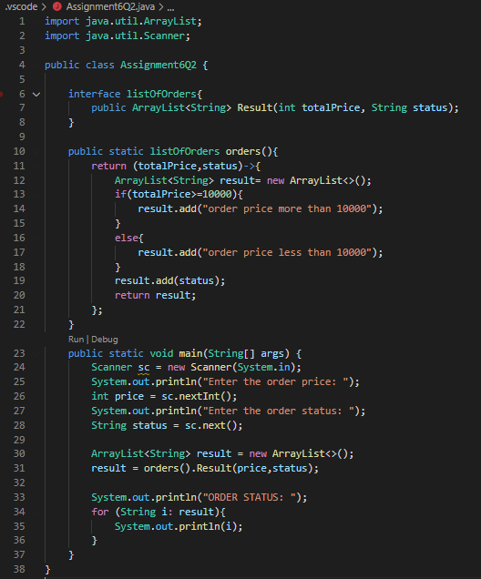

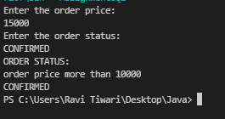

**Q4. Remove the words that have odd lengths from the list. HINT: Use one of the new methods from JDK 8. Use removeIf() method from Collection interface.**

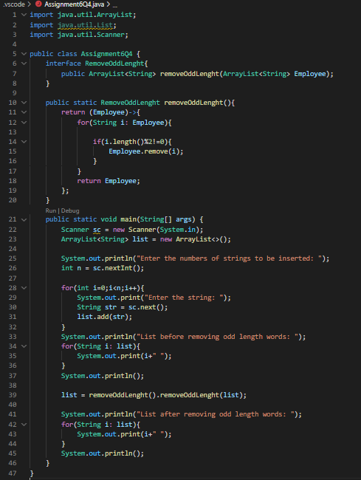

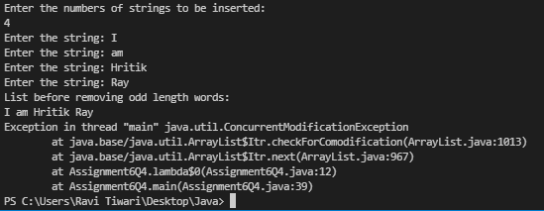

**Q5. Create a string that consists of the first letter of each word in the list of Strings provided. HINT: Use Consumer interface & a String Builder to construct the result.**

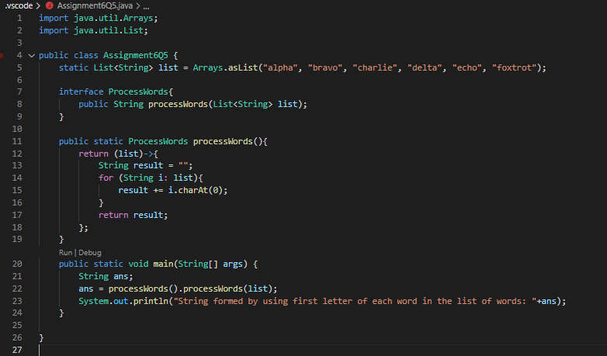



**6. Replace every word in the list with its upper case equivalent. Use replaceAll() method & Unary Operator interface.**

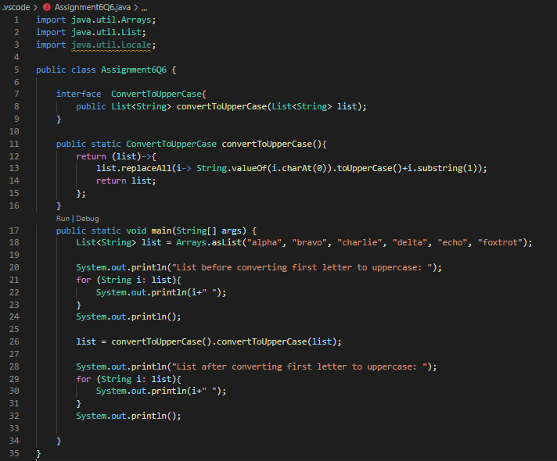

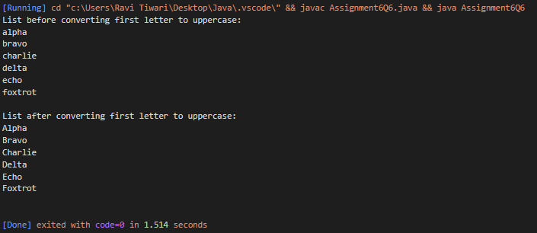

**7. Convert every key-value pair of the map into a string and append them all into a single string, in iteration order. HINT: Use Map.entrySet() method & a StringBuilder to construct the result String.**

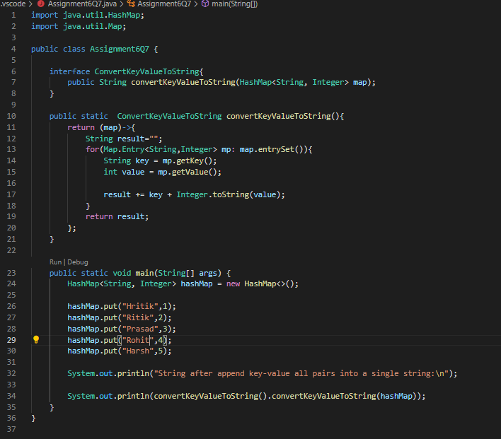

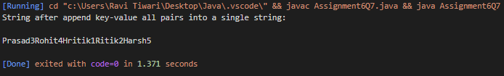

**Q8. Create a new thread that prints the numbers from the list. Use class Thread & interface Consumer.**

